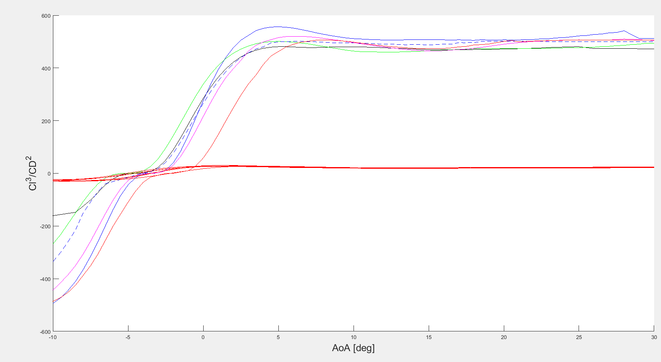The airfoils selected over the NACA2412 all have peak CL3/CD2 at lower AoA. This is chosen to maximize performance at an AoA well below stall. However, based on this analysis the NACA2412 should be able to operate with a max AoA of 10 and be under its stall AoA of 15deg.

EPP856, ‘g’

EPP1098, ‘k’

EPP552, ‘b’

NACA2412, ‘r’

ClarkY, ‘m’

GOE655, ‘- - b’

The clear winner is the Eppler 552.

\*\*\*Note these results are highly influenced by the parasitic drag term cd0.